PTPI’s Pravets, Bulgaria Student Chapter
WILL BE GLAD WHETHER YOU BECOME PART OF OUR BIG FAT PTPI FAMILY!

2013
Peace Through Understanding

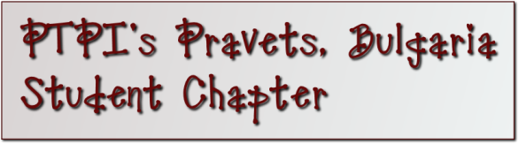
Participant’s Details
Name:
Father’s name:
Surname:
Age:
School:
Address:
E-mail:
Mobile Phone:

What is your previous experience with non-formal education and non-governmental organizations?

What is your personal motivation to attend a non-governmental organization (NGO)?

Have you ever been part of an NGO?

If you have – fill this field
Organization’s Details
Name of organization/institution:
Type of organization (NGO, public body etc.)
Country:
Address:
E-mail:
Phone/Fax:
Web page:

What was your role in the organization/institution (employed youth worker, volunteer, project coordinator)?

How can you contribute as part of PTPI’s Pravets, Bulgaria Student Chapter?

What is your previous experience based on volunteer working and social activity (events, campaigns)?

Do you have any special needs?

The dream started here. For more than 55 years it has grown. You make that possible. Let’s keep the dream alive.
President Eisenhower

Please send the filled application form to ptpibep@gmail.com
Good luck and we hope to see you on our next meeting!

